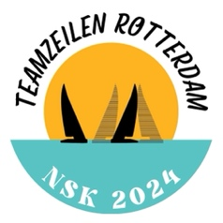

Nr | 1 | Date | 10 may 2024 | Time | 18:00

From | ☐ | Organising authority | ☒ | Race committee | ☐ | Protest comittee

Fleet | Gold

Subject | Ammendment Articles 5 & 6 of SSI

Articles 5 and 6 of the 2K SSI are replaced by the following amendments

5 Courses
5.1 The courses are specified in Addend B of the LSI.
5.2 The course to be sailed (innerloop or outerloop) willl be communicated via a sign at the starting vessel (a board at the port window). The letter “I” means Innerloop, the letter “O” means Outerloop.

6 Marks / starting and finish line
6.1 The marks will be described in the LSI.
6.2 The starting line is between an orange flag on the RCV and a mark with an orange flag. The finishing line is between a blue flag on the RCV and a mark with a blue flag.

Ondertekend | Jan Geert Boeve

