

Nr | 2 | Date | 10 may 2024 | Time | 18:00

From | ☐ | Organising authority | ☒ | Race committee | ☐ | Protest comittee

Fleet | Gold

Subject | Ammendment Addendum B of the LSI

Addendum B of the LSI

Race Course Innerloop

Course: Start – 2 – 2a - 3 – 2 – 4 – finish
When flag S is displayed: Start - 2 – 4 – Finish

Race Course Outerloop
Course: Start – 2 – 4 – 4a – 5 – 4 – 4a – finish.
When Flag S is displayed: Start – 2 – 4 – Finish.

Starting line approximately 5 boat lengths
Target race time 10 - 12 minutes. This is a target, and no reason for protest
All marks to be kept at starboard.
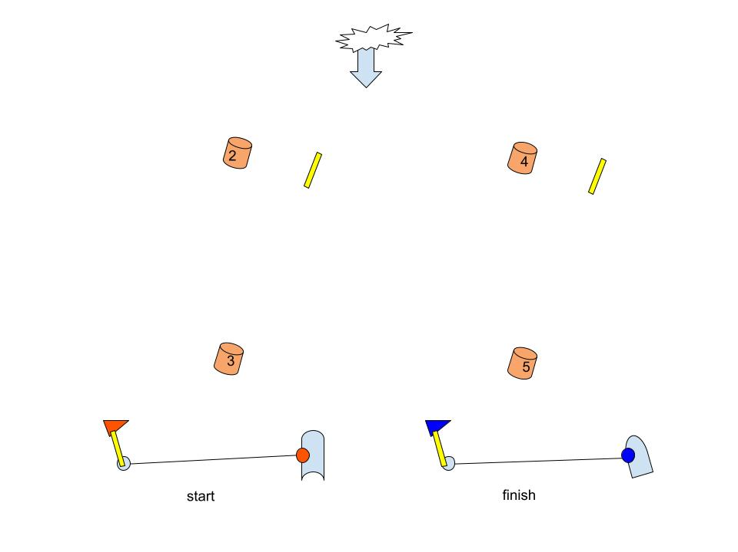

Ondertekend | Jan Geert Boeve

